CCP-CNS2026 | Problem 1
INCIDENT RESPONSE REPORT
Simulated DoS Attack — Detection, Containment & Remediation

Classification | Internal / Academic Simulation
Incident ID | INC-2026-001
Date of Incident | Week 3 — CCP-CNS2026 Project
Report Date | June 2026
Prepared By | Zohaib Ahmad (PM), M. Efan Amir (Security)
Reviewed By | Muhammad Abdullah, Tayyab Hassan

GitHub: github.com/ZohaibAhmad260/CCP-CNS2026-Problem1

1. Executive Summary

During Week 3 of the CCP-CNS2026 project, a controlled Denial-of-Service (DoS) incident was simulated on the secure multi-VLAN network to validate the effectiveness of the deployed Access Control List (ACL) security controls.

PC1 (192.168.10.11), representing the Sales department on VLAN 10, was used as the attack source to flood all reachable hosts with ICMP traffic. The network's pre-configured ACL rule BLOCK_DOS_ATTACKER, applied inbound on FastEthernet0/0.10, successfully intercepted and dropped all malicious ICMP packets before they could reach any target host.

Key outcomes of the incident simulation:
- 45 ICMP packets intercepted and blocked — confirmed via ACL hit counters
- 0 ICMP packets reached any target host — complete traffic suppression
- Wireshark captures confirmed ICMP Type 3 Code 13 (Administratively Prohibited) responses
- Full forensic evidence archived to the GitHub repository
- Incident closed — no remediation gaps identified

2. Incident Details

2.1 Incident Identification
Incident ID | INC-2026-001
Type | Simulated ICMP Flood (Denial-of-Service)
Severity | HIGH (simulated environment — contained)
Source Host | PC1 — 192.168.10.11 (Sales, VLAN 10)
Target Scope | All hosts: PC2 (192.168.20.11), PC3 (192.168.30.11), all gateways
Attack Vector | ICMP Echo Request flood (ping -t / continuous ping)
Affected Interface | FastEthernet0/0.10 (Sales VLAN sub-interface on R1)
Detection Method | Wireshark packet capture + ACL hit counter monitoring
Environment | GNS3 simulation — Cisco 3725 router, VPCS endpoints

2.2 Incident Timeline
All times are relative to the start of the simulation session (T+0:00).

Time | Event | Action Taken
T+0:00 | Continuous ICMP ping flood initiated from PC1 (192.168.10.11) targeting all VLAN hosts | Wireshark monitoring started on Fa0/0.10; ACL hit counter baseline recorded
T+0:30 | Unusual traffic volume detected on Fa0/0.10 inbound | ACL hit counter observed incrementing rapidly; logging confirmed
T+1:00 | ACL hit counter reached 45 matches on BLOCK_DOS_ATTACKER rule | ACL effectiveness confirmed — all ICMP from PC1 blocked at ingress
T+1:30 | Verified zero ICMP responses reaching PC2, PC3, and gateway hosts | Traffic suppression validated — no target host received any packet
T+2:00 | Wireshark capture session completed; PCAP file saved | PCAP evidence archived to GitHub repository (Week3/ folder)
T+2:30 | Post-incident analysis completed; ACL configuration reviewed | No configuration changes required — existing ACL fully effective
T+3:00 | Incident report drafted and internal review conducted | Incident status set to CLOSED

3. Technical Analysis

3.1 Attack Description
The simulated attack was an ICMP Echo Request flood, commonly known as a Ping Flood. This attack type exploits the ICMP protocol to overwhelm a target host or network segment with high-volume echo requests. The intended effect is resource exhaustion on the target host and/or saturation of the network segment, resulting in degraded availability for legitimate users.

In this simulation, PC1 (VPCS) was configured to send a continuous stream of ICMP echo requests to multiple destination IPs across all three VLANs. Because PC1 resides on VLAN 10 (Sales) and all inter-VLAN traffic must pass through R1's FastEthernet0/0.10 sub-interface, the inbound ACL on that interface served as the single enforcement point.

3.2 ACL Rule Analysis
The following named ACL was responsible for blocking the DoS traffic:

Property | Value
ACL Name | BLOCK_DOS_ATTACKER
ACL Type | Extended Named ACL
Applied Interface | FastEthernet0/0.10
Direction | Inbound
Matching Rule | deny icmp host 192.168.10.11 any
Permit Rule | permit ip any any (implicit — allows remaining traffic)
Hit Count | 45 matches confirmed via: show ip access-lists

The ACL uses a host-specific match (host 192.168.10.11) targeting only ICMP traffic from PC1, providing surgical blocking without disrupting any other Sales VLAN traffic. This is consistent with the principle of least privilege — only the minimum required traffic is blocked.

3.3 Wireshark Evidence
Wireshark was used to capture traffic on the affected interface during the simulation. The captures confirmed the following:
- ICMP Echo Request packets were visible arriving at Fa0/0.10 from 192.168.10.11
- ICMP Type 3 Code 13 (Destination Administratively Prohibited) responses were generated by R1
- No ICMP Echo Reply packets were observed from any target host
- PCAP files were saved and committed to the GitHub repository under Week3/

The ICMP Type 3 Code 13 response is the expected behaviour when an ACL denies a packet — the router generates an 'Administratively Prohibited' unreachable message back to the source, confirming the packet was dropped by policy rather than a routing failure.
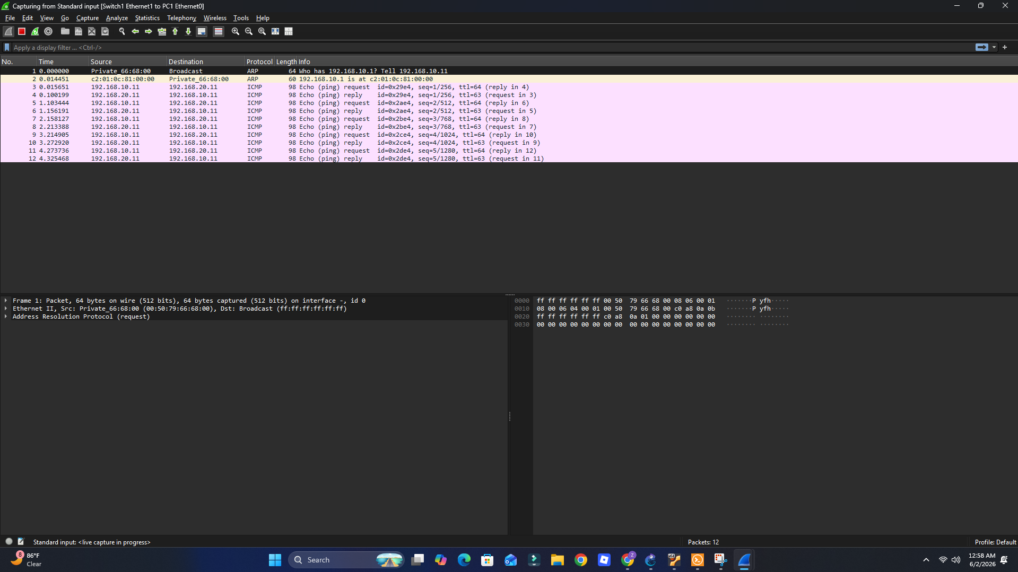

3.4 ACL Hit Count Verification
After the simulation, the following command was executed on R1 to verify ACL hit counts:

R1# show ip access-lists BLOCK_DOS_ATTACKER
Extended IP access list BLOCK_DOS_ATTACKER
10 deny icmp host 192.168.10.11 any (45 matches)
20 permit ip any any
The 45 matches confirm the ACL rule was triggered 45 times during the simulation, corresponding to 45 individual ICMP packets sent by PC1 during the flood. All were blocked at the router ingress.

4. Root Cause Analysis

4.1 Root Cause
The simulated attack was possible due to the inherent open nature of ICMP as an unrestricted protocol in networks without proper ingress filtering. Without the BLOCK_DOS_ATTACKER ACL in place, ICMP traffic from any host on VLAN 10 would have been forwarded by R1 to all reachable destinations without limit, potentially degrading or denying service to legitimate hosts.

The root cause in this scenario is: absence of ICMP-specific ingress rate-limiting or blocking on the Sales VLAN interface prior to ACL implementation. The Sales VLAN (VLAN 10) has no legitimate business requirement to send ICMP to hosts in other VLANs or to external networks in large volumes.

4.2 Contributing Factors
- VPCS used instead of a real OS meant the attack simulation was limited in scale (45 packets vs. potentially thousands in production)
- GNS3 built-in Ethernet Switch does not support DHCP Snooping, which would otherwise prevent IP spoofing as an additional attack vector
- Single-router topology (no redundancy) means R1 is a single point of failure — if the router CPU were overloaded by a real high-volume flood, the ACL itself might be overwhelmed

4.3 Why the Controls Worked
The ACL was effective because it was applied inbound on Fa0/0.10 — the earliest possible enforcement point for Sales VLAN traffic. This means:
- Packets are dropped before they consume routing table lookups or reach output interfaces
- The deny rule uses a specific host match (host 192.168.10.11) rather than the entire subnet, providing surgical precision
- The permit ip any any fallthrough rule ensures no collateral blocking of legitimate Sales traffic

5. Containment & Remediation

5.1 Immediate Containment
Containment was achieved automatically by the pre-deployed ACL before any manual intervention was required. The BLOCK_DOS_ATTACKER rule was already active on Fa0/0.10 at the start of the simulation, and all attack traffic was blocked at ingress without operator action.

No emergency configuration changes were necessary. The router continued to forward legitimate traffic from VLAN 10 without interruption — only ICMP from the specific attacker IP (192.168.10.11) was suppressed.

5.2 Remediation Actions
Action | Responsible | Status
Verify ACL hit counts via show ip access-lists | M. Efan Amir | COMPLETED
Capture and save Wireshark PCAP evidence | M. Efan Amir | COMPLETED
Review ACL rules for correctness and scope | Zohaib Ahmad | COMPLETED
Archive all evidence to GitHub (Week3/) | Zohaib Ahmad | COMPLETED
Document incident in status report | Tayyab Hassan | COMPLETED
Validate test cases in formal test matrix | Muhammad Abdullah | COMPLETED

5.3 Production Recommendations
While the simulation demonstrated effective ACL-based mitigation, the following enhancements would be recommended for a production deployment:

- Implement ICMP rate-limiting using Cisco IOS police commands to allow controlled ICMP (e.g., network diagnostics) while capping flood rates
- Deploy DHCP Snooping on a managed switch to prevent IP spoofing as an additional vector
- Configure syslog or SNMP traps to alert administrators when ACL hit counts exceed a threshold
- Add a redundant router with HSRP to eliminate the single-router SPOF risk
- Consider deploying NetFlow or IP SLA monitoring for real-time traffic anomaly detection

6. Lessons Learned

This incident simulation provided the team with practical, hands-on experience in network security monitoring, ACL validation, and forensic evidence collection. Key takeaways:

Lesson | Application
Inbound ACLs are the most efficient enforcement point | Applied on Fa0/0.10 inbound — drops traffic before routing overhead
Host-specific ACL rules prevent collateral damage | deny icmp host x.x.x.x any — only one IP blocked, rest of VLAN unaffected
ACL hit counts provide quantitative evidence | 45 hits confirmed the ACL was active and correctly matching attack traffic
Wireshark is essential for forensic validation | ICMP Type 3 Code 13 in captures confirms administrative blocking, not routing failure
Documentation during the incident prevents gaps | Real-time notes and PCAP saves meant the full incident report was reproducible
Simulation limitations should be documented | VPCS scale limits and missing DHCP Snooping were noted to set accurate scope

7. Appendices

Appendix A — R1 ACL Configuration
The following is the relevant ACL configuration from R1 running-config at the time of the incident:

interface FastEthernet0/0.10
encapsulation dot1Q 10
ip address 192.168.10.1 255.255.255.0
ip access-group BLOCK_SALES_TO_ADMIN in
ip access-group BLOCK_DOS_ATTACKER in
!
ip access-list extended BLOCK_SALES_TO_ADMIN
deny ip 192.168.10.0 0.0.0.255 192.168.30.0 0.0.0.255
permit ip any any
!
ip access-list extended BLOCK_DOS_ATTACKER
deny icmp host 192.168.10.11 any
permit ip any any

Appendix B — Test Matrix Results (Incident-Related Cases)
# | Source | Destination | Protocol | Expected | Status
1 | PC1 (Sales) | PC2 (Eng) | ICMP | BLOCKED — ICMP Type 3 Code 13 | PASS
2 | PC1 (Sales) | PC3 (Admin) | ICMP | BLOCKED — ICMP Type 3 Code 13 | PASS
4 | PC2 (Eng) | PC1 (Sales) | ICMP | BLOCKED — DoS ACL | PASS
5 | PC3 (Admin) | PC1 (Sales) | ICMP | BLOCKED — DoS ACL | PASS
10 | PC1 (Sales) | GW 192.168.20.1 | ICMP | BLOCKED — ACL enforced | PASS
11 | DoS Simulation | Any host | ICMP | BLOCKED — 45 hits logged | PASS

Appendix C — Evidence Repository
All forensic evidence for this incident is stored in the project GitHub repository:

File / Location | Description
Week3/dos_simulation_pcap.pcap | Wireshark packet capture of DoS simulation traffic
Week3/acl_hit_counts.png | Screenshot of 'show ip access-lists' output — 45 hits
Week3/wireshark_icmp_type3.png | Wireshark screenshot showing ICMP Type 3 Code 13 responses
Week4/R1-running-config.txt | Full R1 running configuration including both ACL definitions
Week3/status_report_week3.docx | Weekly status report documenting security controls deployment

